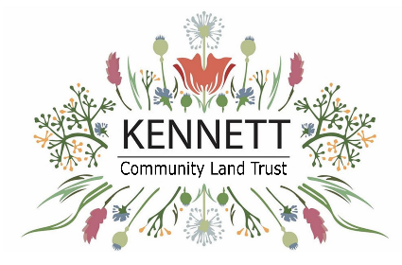
Kennett Community Land Trust
I wish to become a member of the Community Land Trust in Kennett Parish.
Whilst a member I will act in the interests of the CLT and for the benefit of the community, as a guardian of the objectives of the Community Land Trust.
Eligibility to become a Full Member of the Kennett Community Land Trust are: “Those that live, work, educate their children, own property or do business in the parish of Kennett”
Associate Membership is extended to all other applicants who do not meet these criteria.
I have payed a Membership Fee of £1, by BACS transfer to: Kennett Community Land Trust, Sort- Code: 30-99-08, Account Number: 23357568. Use your surname as the Payment Reference. OR
in cash enclosed with this form (please tape coins to the reverse of this form. Not loose in the envelope)
(Delete as applicable)
Completed forms should be returned to: The Secretary, Kennett Community Land Trust, 66 Station Road, Kennett. CB8 7QF
or electronically (if using BACS) to hello@kennettclt.org
Full Name | Postal Address | E-mail Address | Connection to Parish (if you do not live in Kennett)
Notes: One form per member
I am over 18 years of age and understand that the Trustee Board has the power in its absolute discretion to accept or reject this application.
Signature: Date:

Please use the reverse of this form to add any information you may feel may support your application.

